CHALLENGE ON AWS WAF AND SYSTEMS MANAGER

- You can use AWS WAF, AWS Shield and AWS Firewall Manager together to create a comprehensive security solution.
- AWS WAF: AWS WAF is a web application firewall that lets you monitor the HTTP and HTTPS requests that are forwarded to your protected web application resources.
- AWS SHIELD: Shield Advanced provides protection against distributed denial of service (DDoS) attacks for AWS resources, at the network and transport layers (layer 3 and 4) and the application layer(7).
- AWS Firewall Manager: AWS Firewall Manager provides management of protections like AWS WAF and Shield Advanced across accounts and resources, even a new resources are added.

AWS WAF:

EXAMPLE: Block Traffic from Specific Countries

User from India request the server
|
Application Load Balancer
|
AWS WAF
|
Block the request
|
Browser will show 403 error

STEP BY STEP IMPLEMENTATION:
- Launch 2 instances and add them into the target groups. So that Application Load balancer will identify them.
- After launching and creating target groups, we have to create a Application Load balancer and attach this created target group to that ALB.
- After creating ALB, now we have create WEB ACL in AWS WAF service.
- Create a custom rule group by adding the geo match rule to rule group that we have to set the configurations as block the requests coming from india.
- And this created rule group we have to attach this to the WEB ACL and we have to integrate the WEB ACL with the ALB that we have created.
- After creating WEB ACL, we have to verify that whether our WEB ACL is integrated with our ALB or not in the integrations tab of ALB.
- We can check in the browser by using DNS name of load balancer.

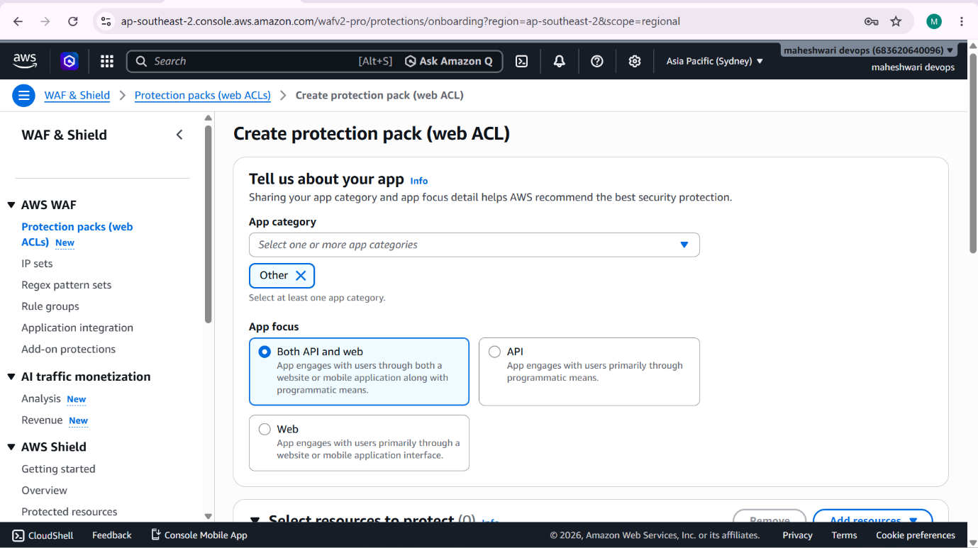

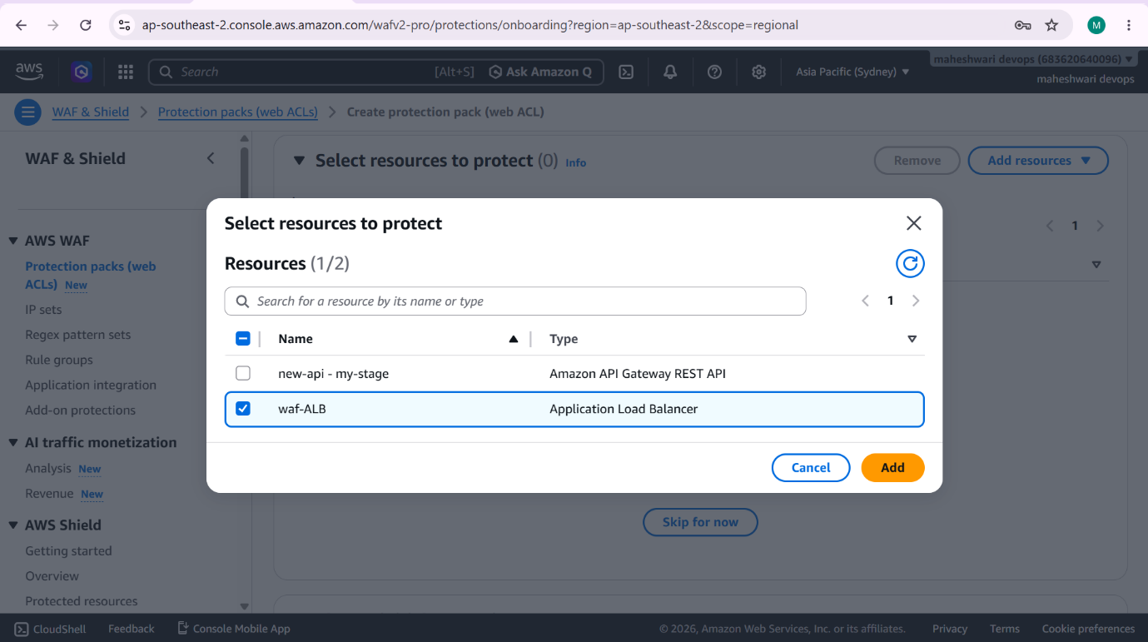

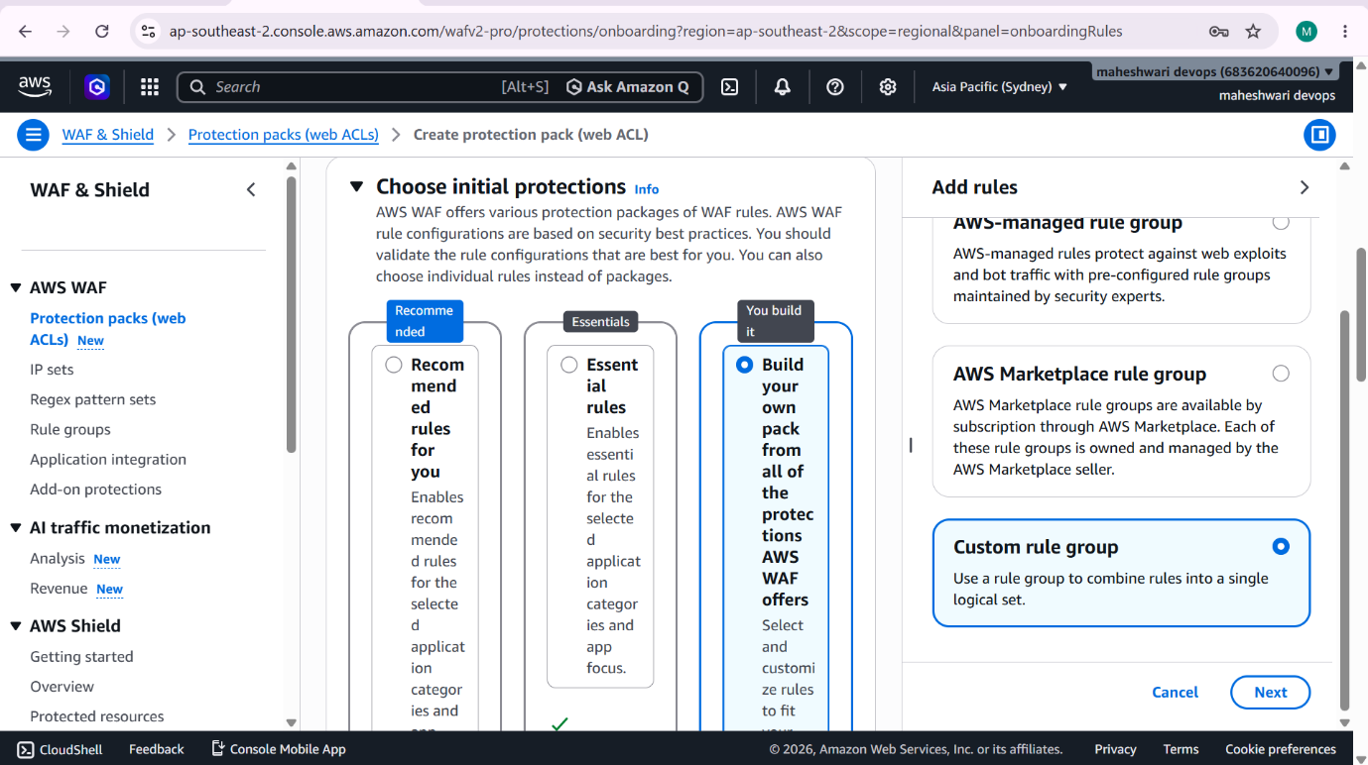

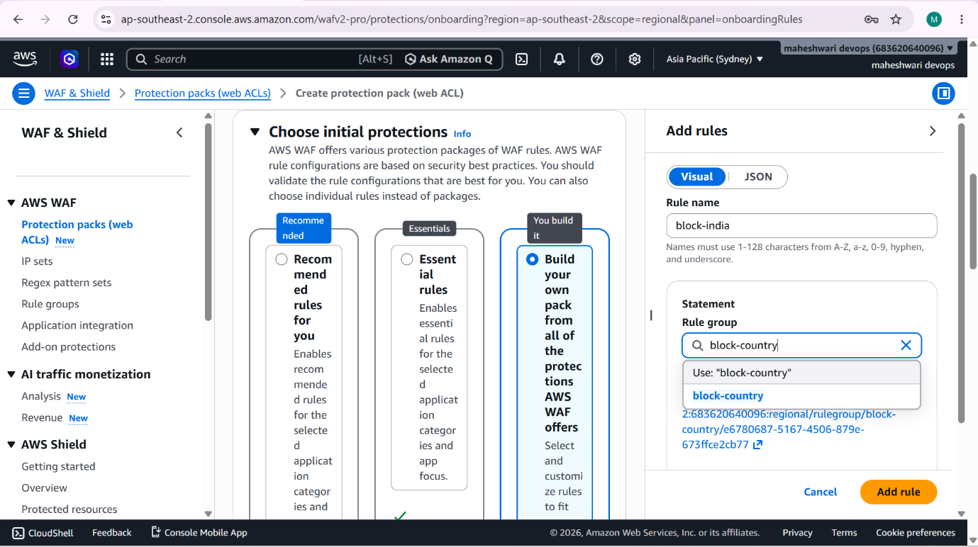

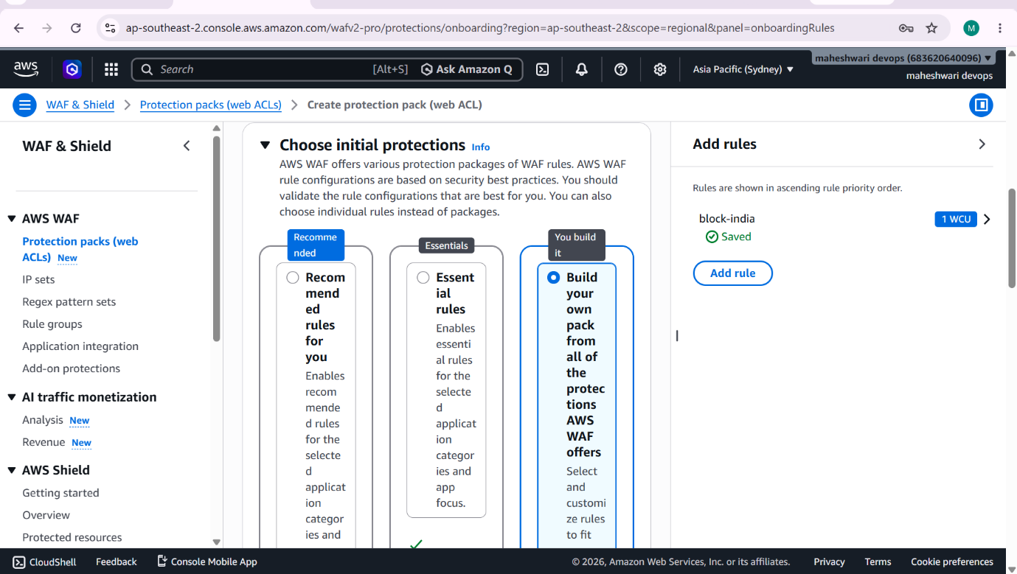

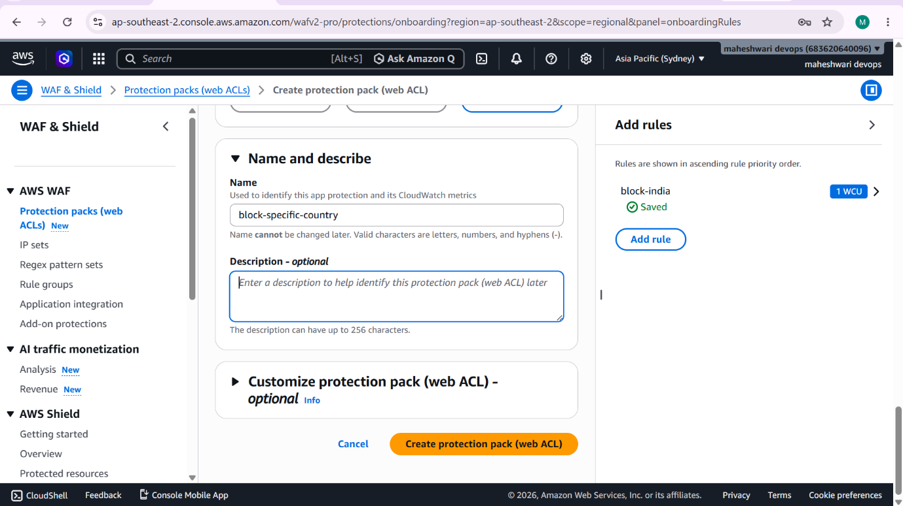

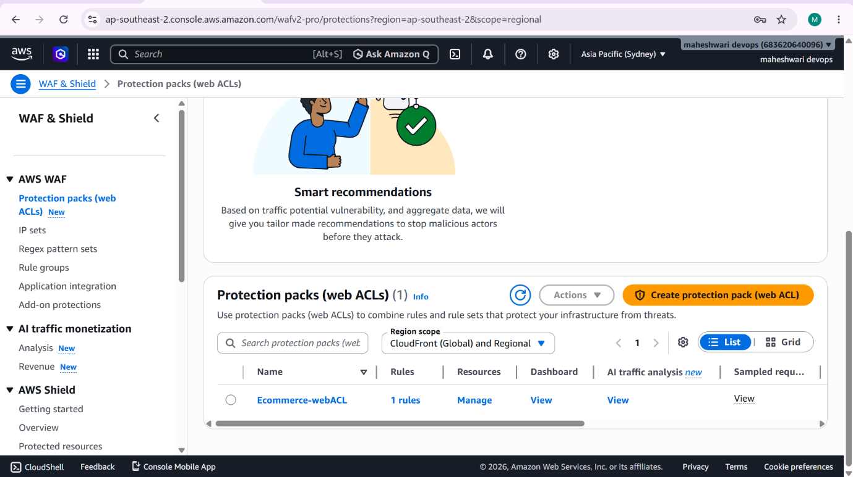

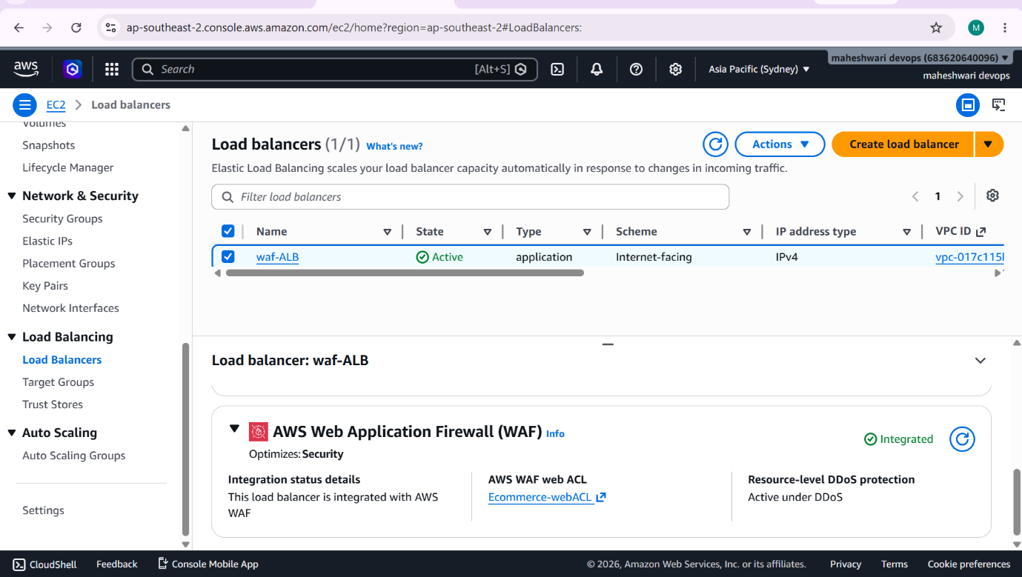

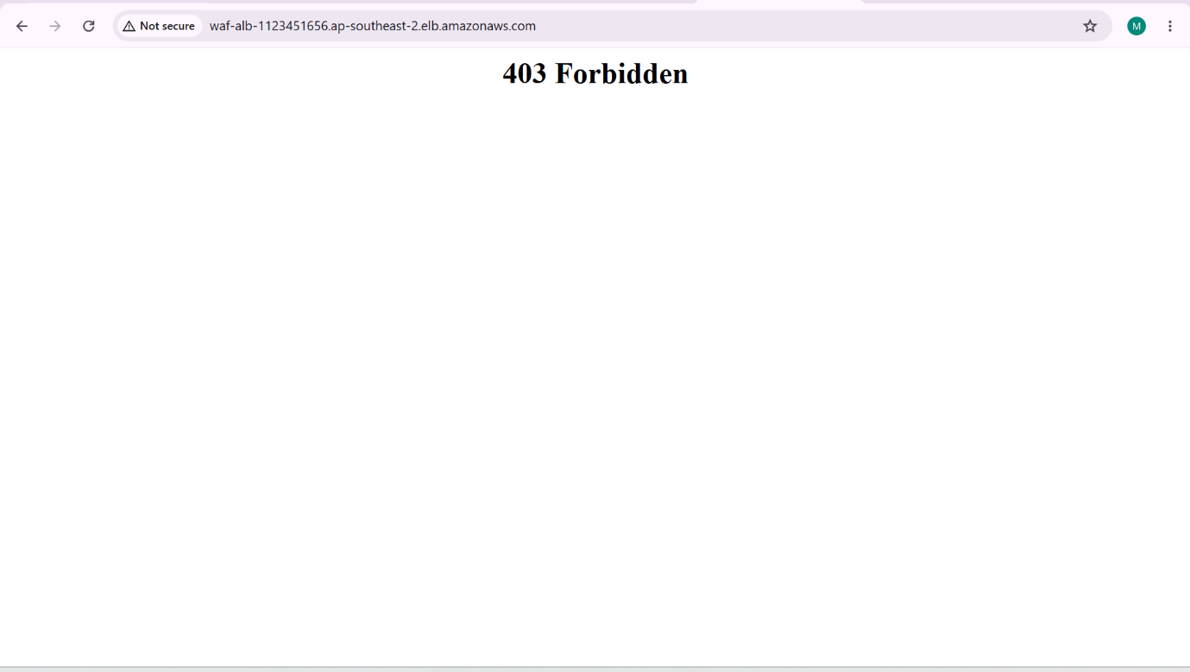

- We can also check by removing the rule in the AWS WAF.

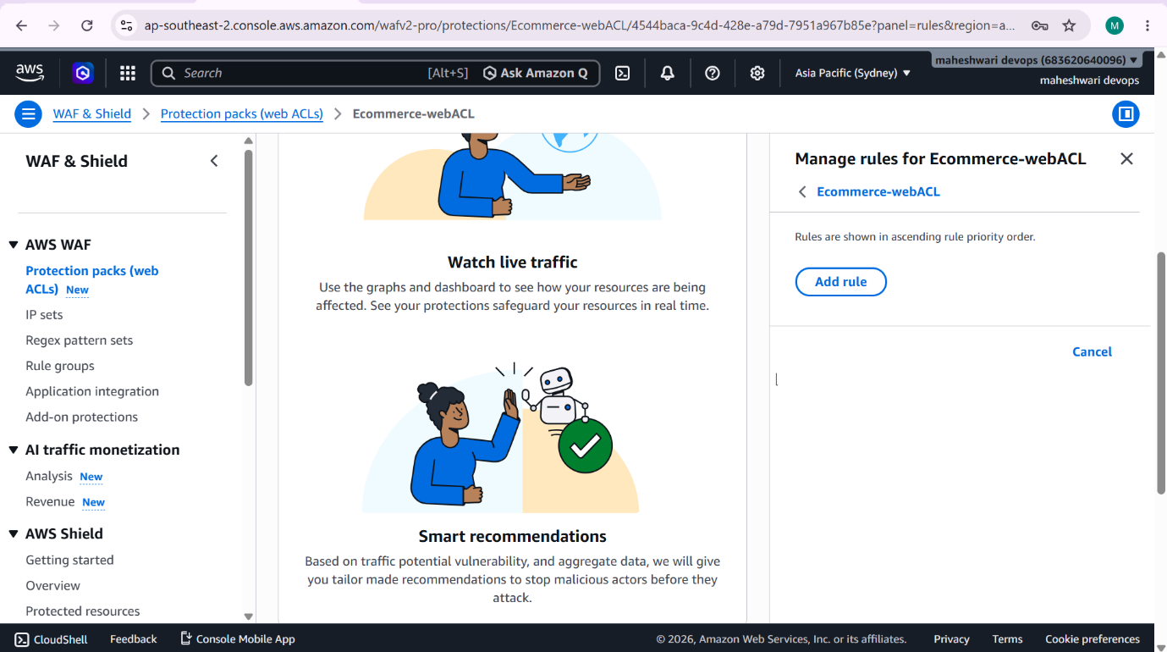

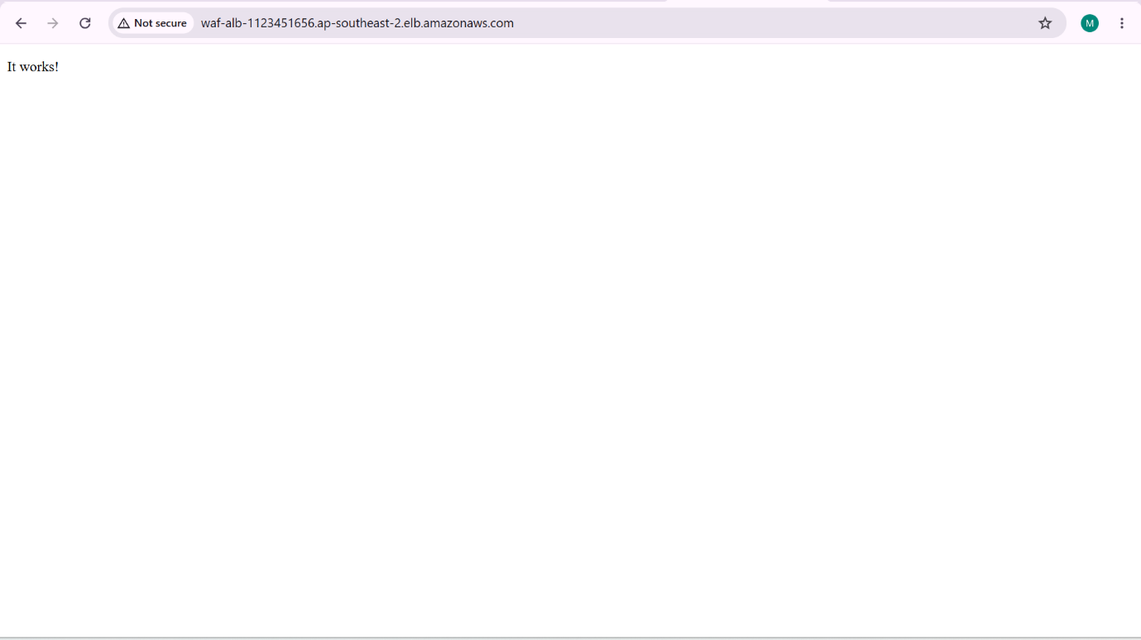

AWS SHIELD:

- AWS Shield is a managed DDoS protection service that safeguards AWS applications from malicious traffic.
- DDoS attack occurs when attackers use thousands or millions of compromised devices to flood an application with traffic, making it slow or unavailable.
- You will notice that AWS resources such as:
  - Application Load Balancers
  - CloudFront Distributions
  - Route 53 Hosted Zones
  - Global Accelerator
  - are automatically protected by Shield Standard.
- No configuration is required.

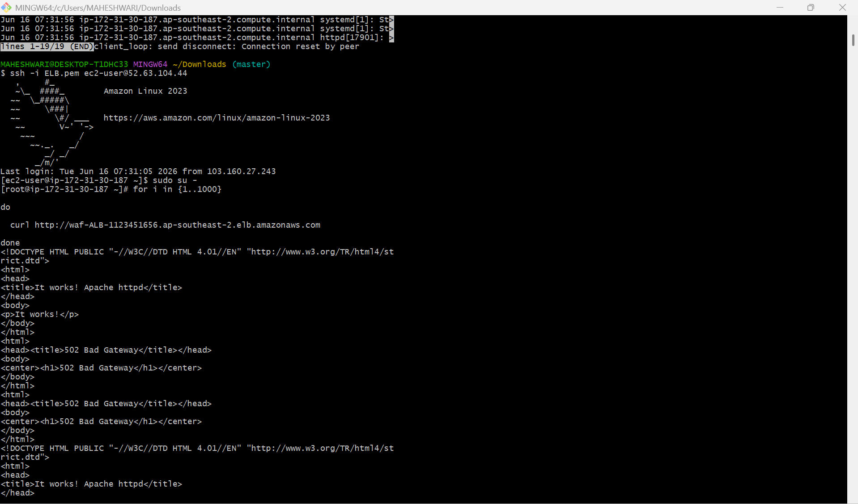

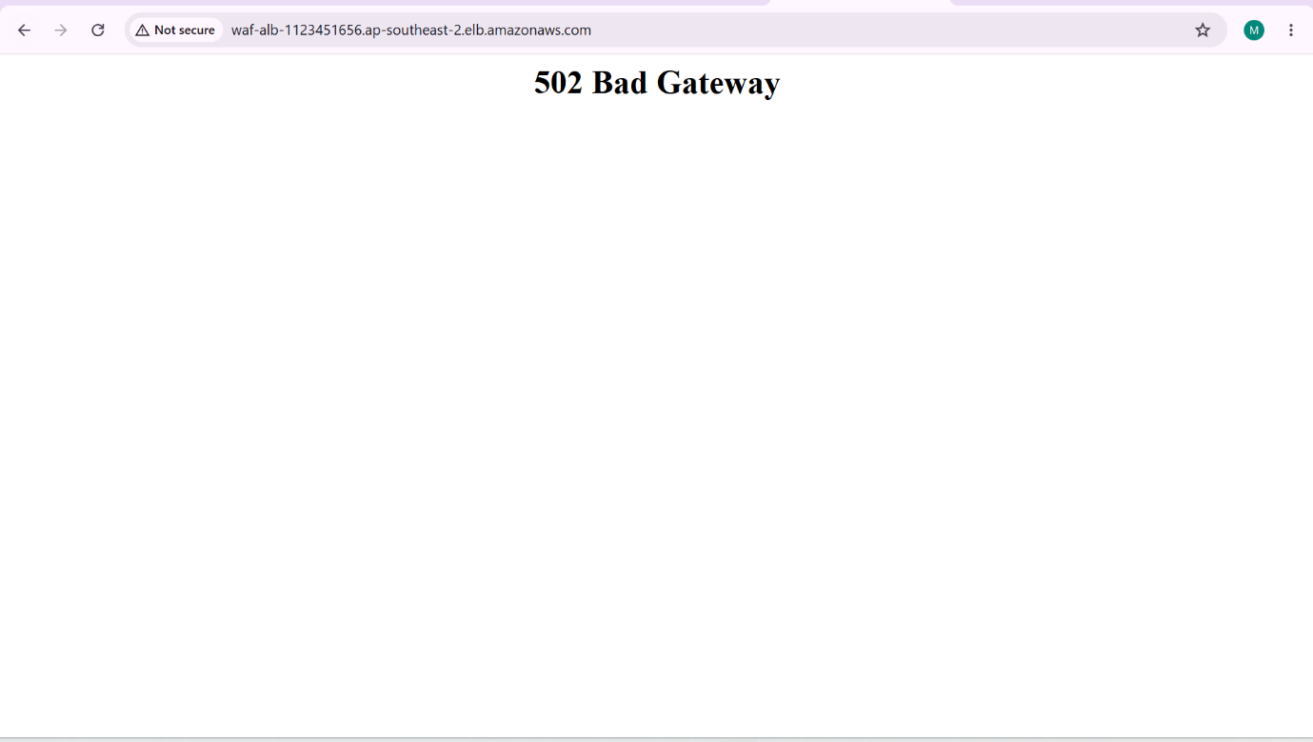

AWS SYSTEMS MANAGER

AWS Systems Manager (SSM) is a service that helps you manage, patch, configure and automate operations on AWS resources and on-premises servers from a central place.

Simple Definition: AWS systems Manager allows you to manage servers without logging in through SSH or RDP.

ARCHITECTURE:
Administrator
|
AWS Systems Manager
|
IAM Role (AmazonSSMManagedInstanceCore)
|
SSM Agent
|
EC2 instances

Major Features:

- Think of AWS Secret Manager as a remote control for your servers. Instead of logging in to each server individually, you can manage all of them from one place.

1.Session Manager: Session Manager allows you to connect to EC2 instances without using SSH or RDP.
Benefit: Secure server access without opening inbound ports.

2.Run command: Run command lets you execute commands on one or many servers at the same time.
Benefit: Perform bulk administrative tasks without logging into each server.

3.Patch Manager: Patch Manager automates operating system updates and security patches.
Benefit: Keeps servers secure and compliant automatically.

4.Parameter Store: Parameter Store securely stores configuration values and secrets.
Benefit: Centralized and secure configuration management

5.Automation: Automation helps automate repetitive operational tasks.
Benefit: Reduces manual effort and human errors.

6.Inventory: Inventory collects software and configuration information from servers.
Benefit: Helps during audits and compliance checks.

7.State Manager: State Manager keeps instances in a desired configuration state.
Benefit: Maintains consistency across environments.

8.Fleet Manager: Fleet Manager provides a graphical interface to manage all your server.
Benefit: Simplifies server administration from the AWS Console.

AWS Systems Manager Run Command – Install Nginx on Multiple Servers

PURPOSE: suppose we have 10 EC2 instances and we want to install Nginx service in all servers. So instead of ssh into every server we can use the systems manager Run Command for installing in all the server.

STEP BY STEP IMPLEMENTATION:

- Launch the instances in AWS EC2 and instances may be of your wish.
- After launching we have to add a IAM Role to the instances so that we can connect with SSM manager.
- In IAM service, we have to create a new IAM role with the policy AmazonSSMManagedInstanceCore.
- And now connect to the EC2 instances and check whether the amazon-ssm-agent is active or not. If not then we have to start the amazon-ssm-agent by using the command -> systemctl start amazon-ssm-agent.
- After all these configurations, we have check for the nodes in the systems Manager that our instances are connected with the systems manager service or not.
- After verifying the nodes, we have to create a Run Command.
- In Run Command, we have to add the SSM document like AWS-RunShellScript and after this it will ask for the resources i.e.., EC2 instances.
- After adding it will ask the for commands execution. We have to give the commands to install and start nginx also to check the status of the nginx.
- Now click on run command, it will run the command and also installs the service in the servers attached to that.

